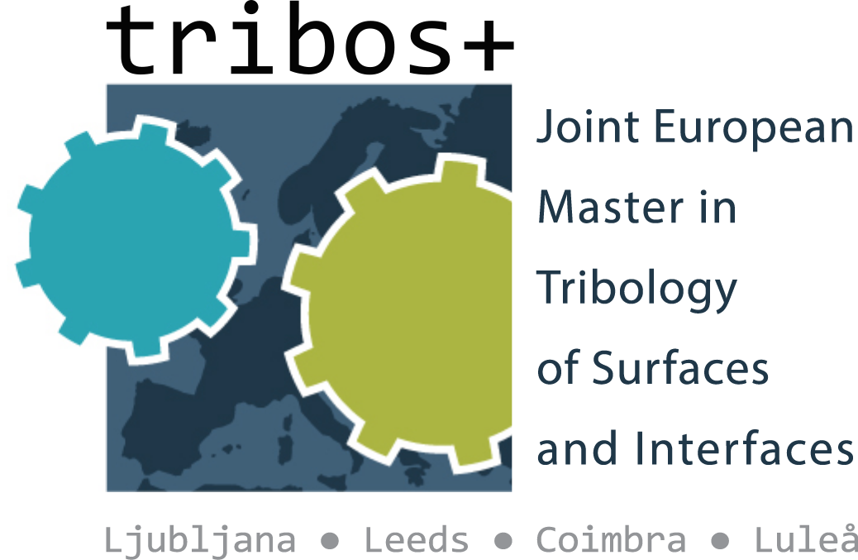
Application Form for Visiting Scholars/Guest Lecturers

- Personal and Contact Information

Title | Click here to enter text.
First name | Click here to enter text.
Family name | Click here to enter text.
Date Birth dd/mm/yyyy | Click here to enter a date.
Country of Birth | Click here to enter text.
Address: | Click here to enter text.
Street, Number | Click here to enter text.
City, State, Postal Code | Click here to enter text.
Country | Click here to enter text.
Nationality | Click here to enter text.
Email | Click here to enter text.
Phone number | Click here to enter text.
Mobile number | Click here to enter text.
Do you consider yourself to have a disability? (Please detail where applicable) | Choose an item.  Click here to enter text.

- Information on Position and Research Area

University | Click here to enter text.
Department | Click here to enter text.
Position/ Function | Click here to enter text.

Proposed Host University | Click here to enter text.
You are encouraged to make contact with your intended collaborator/s at host university | Click here to enter text.
Preferred duration of the scholarship | days (Please note: minimum duration of a scholarship is one week, maximum normally 2-3 weeks)
Preferred arrival date | Click here to enter a date.
Preferred departure date | Click here to enter text.
Proposed activity at host university; eg contribution in terms of student-centred teaching/lecturing, research activities, Master thesis support, academic/professional networking etc). | Click here to enter text.

Date, Signature................................................................................

Supporting documents to be added to this form

- Curriculum Vitae
- Selected publications
- Research and learning outcomes (1 page maximum)

TRIBOS+ Visiting Scholar Privacy Notice

Your Personal Data:
University of Ljubljana will be what’s known as the ‘Controller’ of the personal data you provide to us as part of the application process as a Visiting Scholar. This
privacy notice will explain how the TRIBOS+ consortium will process your personal data.

Why we need it
We need to collect your basic personal data in order to facilitate and manage your application as a Visiting Scholar for the TRIBOS+ programme. We will not collect any personal data from you that we do not need in order to provide and oversee this service to you.

Legal basis for processing your data
We must have a legal basis for processing all personal data. In this instance, we require your data as it is necessary for the performance of the Visiting Scholar competition review which you have entered into.

What we do with it
Your application will be shared with the TRIBOS+ consortium partner universities. If your application is successful then it will also be shared with the Education, Audiovisual and Culture Executive Agency of the European Commission (EACEA) and will be stored on their respective server.

How long we keep it
Your application data will be stored by the TRIBOS+ Consortium until the end of the current recruitment cycle. If you are successful in your application as a Visiting Scholar then your application data will be stored until 5 years after the end of the TRIBOS+ programme’s Erasmus Mundus grant funding period.

What are your rights
You can request access to the information we process about you at any time. If at any point you believe that the information we process relating to you is incorrect, you can request to see this information and to have it corrected. You also have the right to request data portability.

Complaints
If at any point you believe that the information we process relating to you is incorrect, you can request to see this information and have it corrected or deleted. You also have the right to data portability. If you wish to exercise these rights, please contact info@master-tribos.eu

